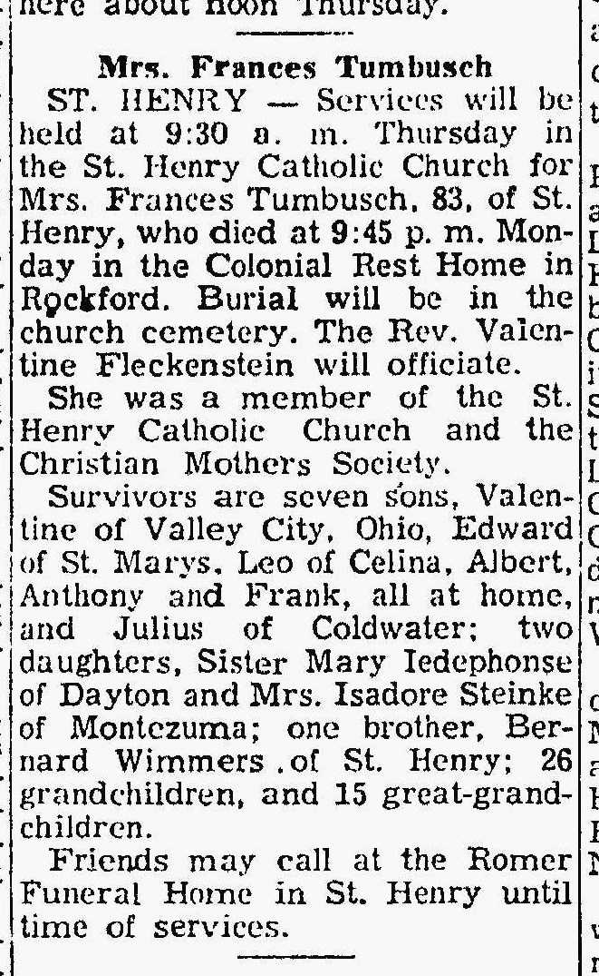
Frances Wimmers Tumbusch
The Lima News
16 Nov 1955, page 2

