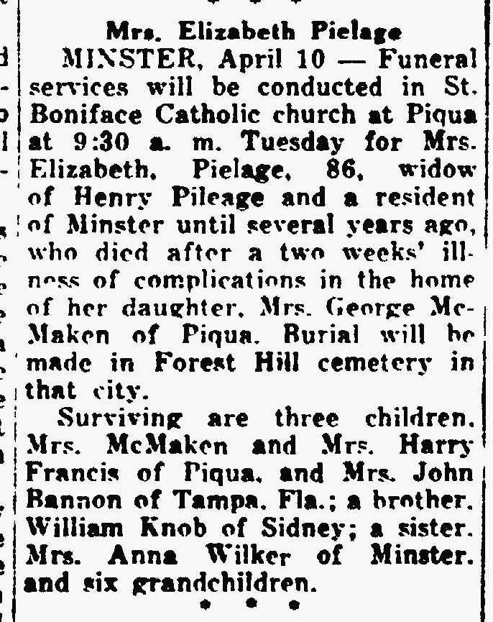
The Lima News
April 10, 1944
Sister of William Knob

