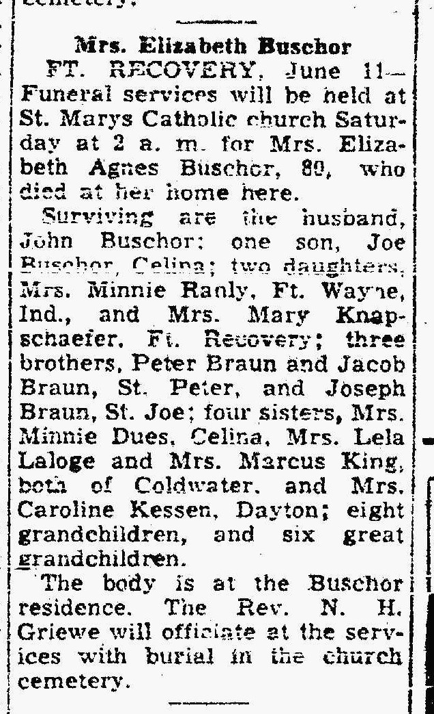
Elizabeth Braun Buschor, half-sister of John M. Braun
The Lima News
11 Jun 1948

