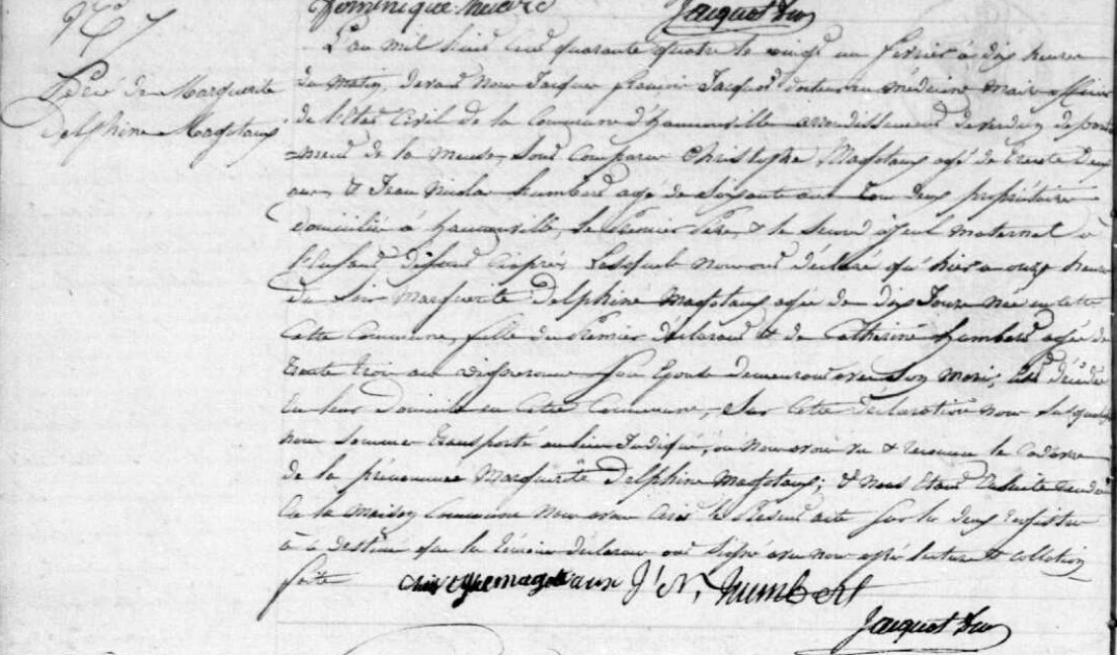
Death Record of Marguerite Delphine Magottaux, sister of Jules Francois Magottaux
Source: http://archives.meuse.fr
Etat Civil
Hannonville-sous-les-Cotes
1843-1852 Births, Marriages, Deaths
Image 83/442

