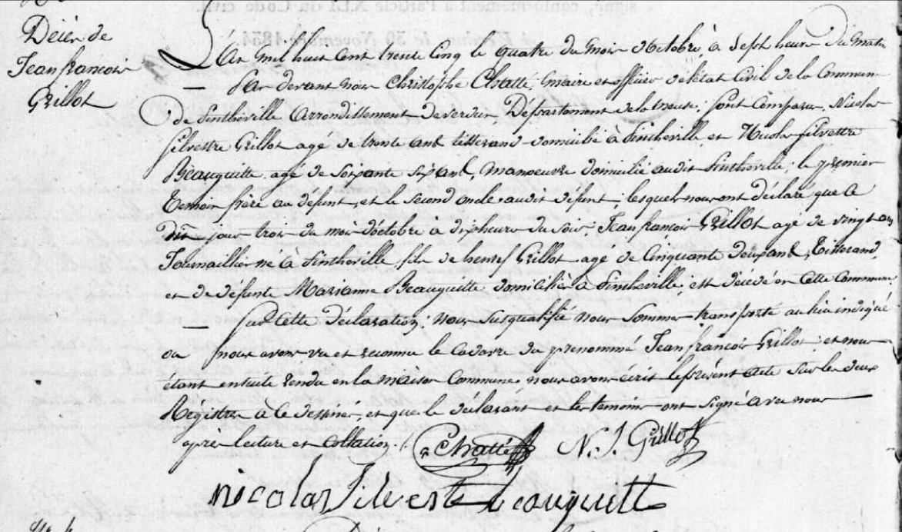
Death Record of Jean Francois Grillot, son of Henry Grillot (brother of Louis Grillot)
Source: archives.meuse.fr
Etat Civil
Pintheville, 1833-1842 Births, Marriages, Deaths
Image 52/166

