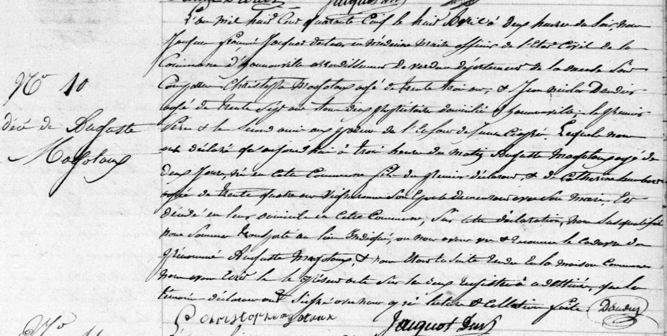
Death Record of Augusta Magotaux, sister of Jules Francois Magotaux
Source: http://archives.meuse.fr
Etat Civil
Hannonville-sous-les-Cotes
1843-1852 Births Marriages Deaths
Image 110/442

