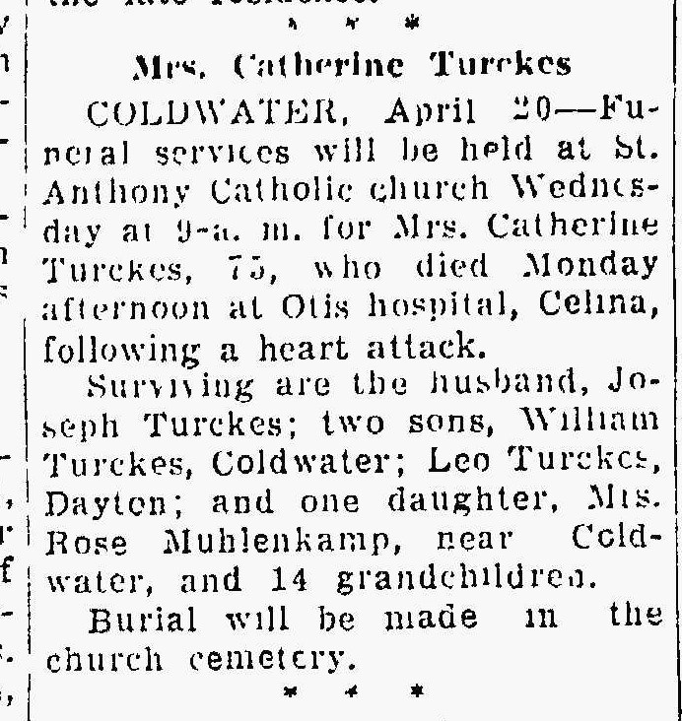
Catherine Uleman Turckes, half-sister of Elizabeth Uleman Braun
The Lima News
20 Apr 1943 Page Four

