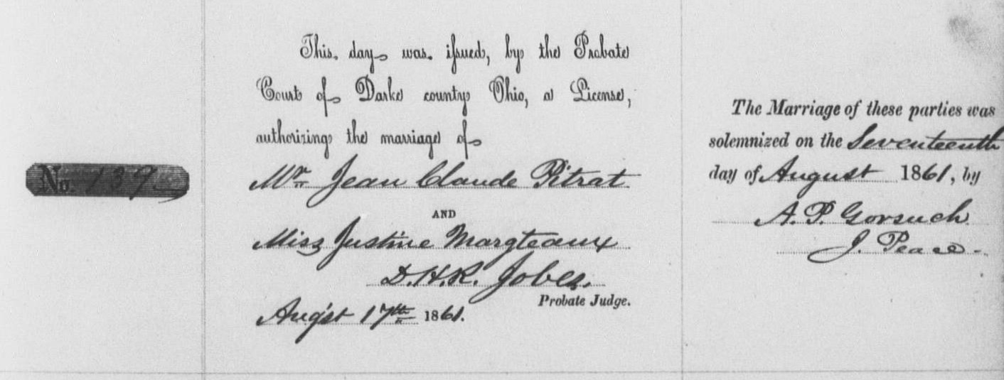

**Jean Claude Pitrat, "Ohio, County Marriages, 1789-1994"**

|  |  |
| --- | --- |
| name: | Jean Claude Pitrat |
| titles and terms: |  |
| event type: | Marriage |
| event date: | 17 Aug 1861 |
| event place: | Darke, Ohio, United States |
| event place (original): |  |
| age: |  |
| birth year (estimated): |  |
| birth date: |  |
| birthplace: |  |
| father's name: |  |
| father's titles and terms: |  |
| mother's name: |  |
| mother's titles and terms: |  |
| spouse's name: | [Justine Margteaux](https://familysearch.org/pal:/MM9.1.1/X8XY-CQC) |
| spouse's titles and terms: |  |
| spouse's age: |  |
| spouse's birth year (estimated): |  |
| spouse's birthplace: |  |
| spouse's father's name: |  |
| spouse's father's titles and terms: |  |
| spouse's mother's name: |  |
| spouse's mother's titles and terms: |  |
| reference id: | item 1 V B-3 P 69 n 139 |
| gs film number: | 1030772 |
| digital folder number: | 004017444 |
| image number: | 00592 |

**Citing this Record**

"Ohio, County Marriages, 1789-1994," index and images, *FamilySearch* (https://familysearch.org/pal:/MM9.1.1/X8XY-CQH : accessed 06 Mar 2013), Jean Claude Pitrat and Justine Margteaux, 1861.