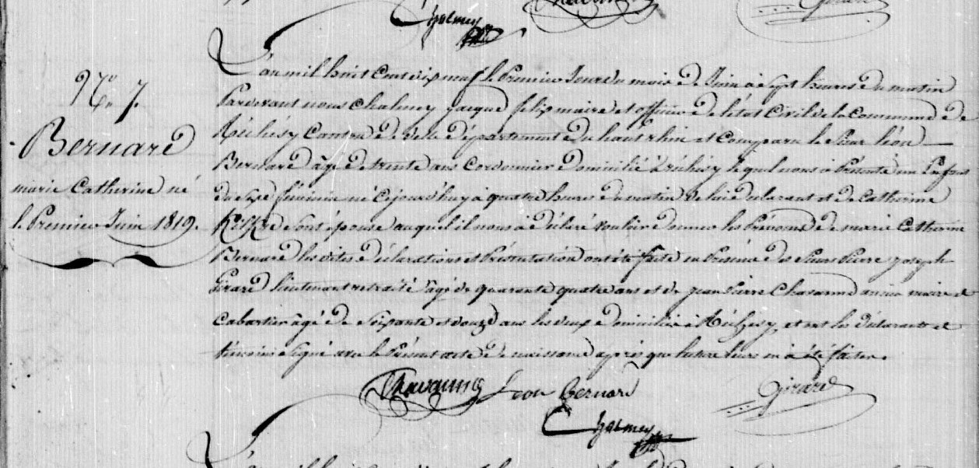
Catherine Bernard, sister of Joseph Bernard, Birth Record
Territoire de Belfort Archives, Rechesy
Etat Civil 1803-1829 1 E 81 N.D.M. 1-2
Source: http://www.archives.cg90.fr/ark:/12997/a011341578574HL7fvX/2/1
Image 13/221

