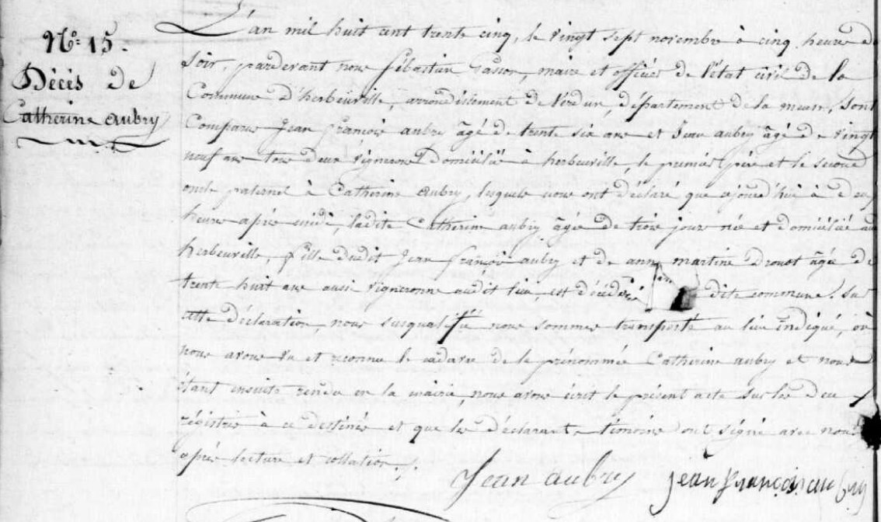
Catherine Aubry Death Record, sister of Marie Anne Aubry Grilliot
Source: archives.meuse.fr
Etat Civil
1833-1842, Births Marriages, Deaths
Image 143/450

