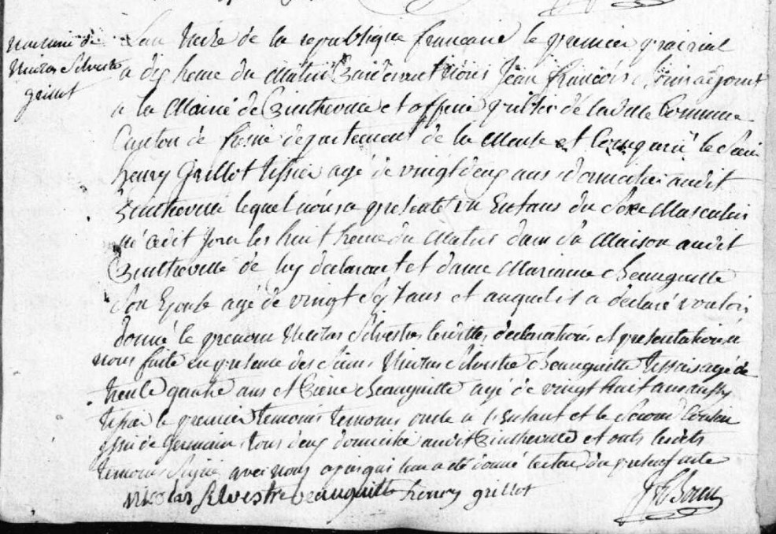
Birth Record of Nicolas Silvestre Grillot, son of Henry Grillot (brother of Louis Grillot)
Source: archives.meuse.fr
Etat Civil, Pintheville, 1802-1812 Births, Marriages, Deaths, Image 22/91

