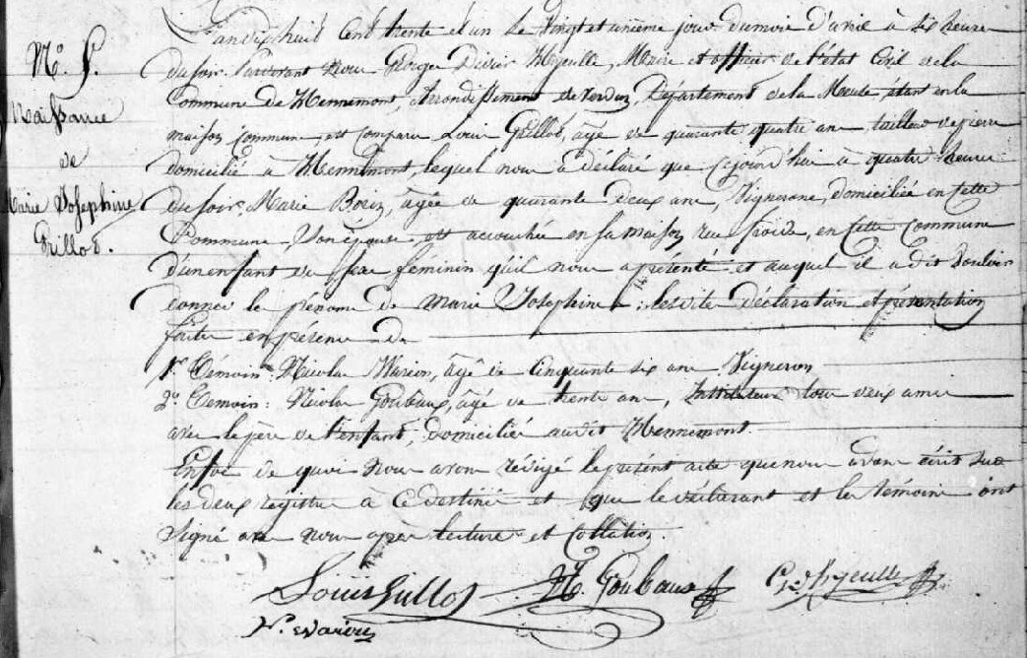
Birth Record of Marie Josephine Grillot, daughter of Louis Grillot and Marie Borin
Source: http://archives.meuse.fr
Etat Civil Hennemont 2 E 250 (6) 1823-1832
Birth, Marriages, Deaths Image 180/213

