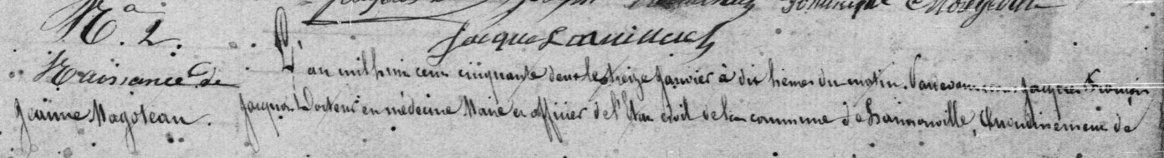
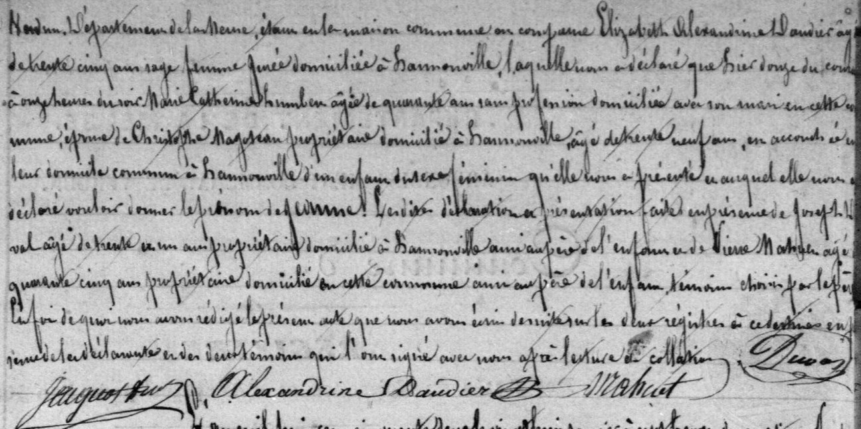
Birth Record of Jeanne Magotaux, sister of Jules F. Magotaux
Source: http://archives.meuse.fr
Etat Civil
Hannonville-sous-les-Cotes
1843-1852 Births Marriages Deaths
Images 406-407/442

