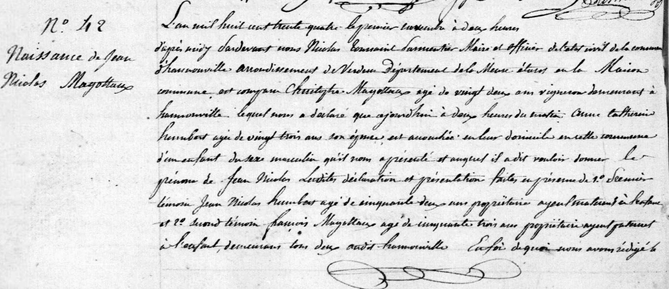
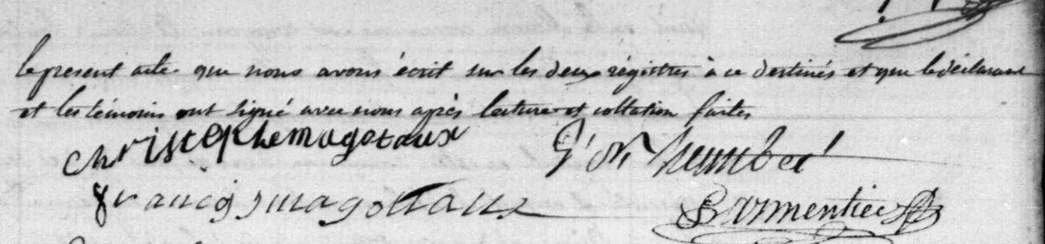
Birth Record of Jean Nicolas Magoteaux (first child of Christopher Magoteaux and Marie Catherine Humbert)
Source: http://archives.meuse.fr
Etat Civil, Hannonville-sous-les-Cotes
1833-1842, Births, Marriages, Deaths Image 91/447

