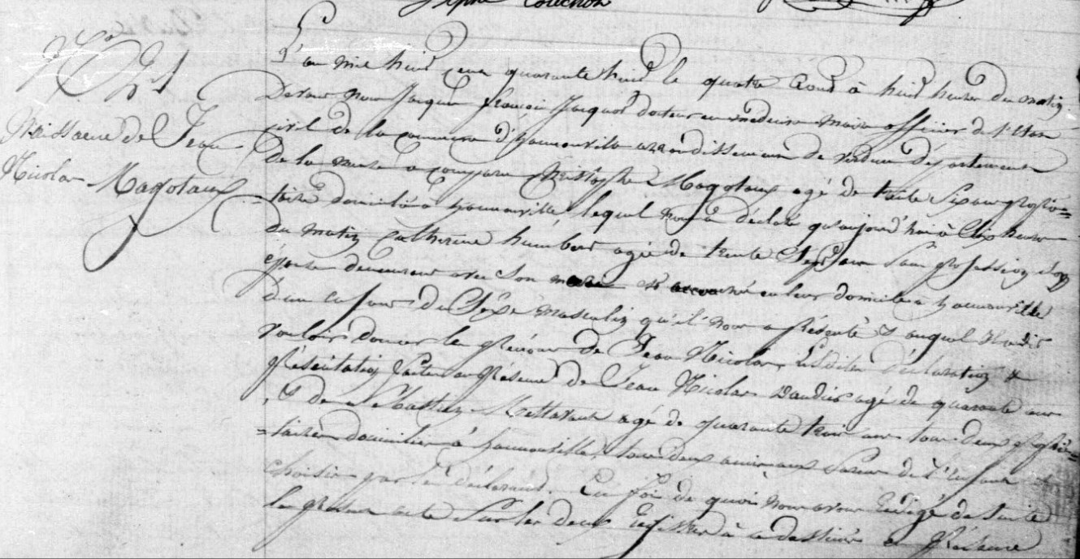
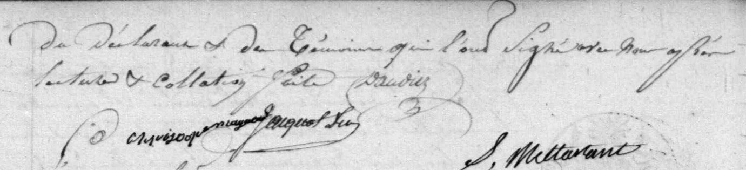
Birth Record of Jean Nicolas Magotaux, brother of Jules Francois Magotaux
Source: http://archives.meuse.fr Etat Civil Hannonville-sous-les-Cotes 1843-1852 Births Marriages Deaths Images 183-184/442

