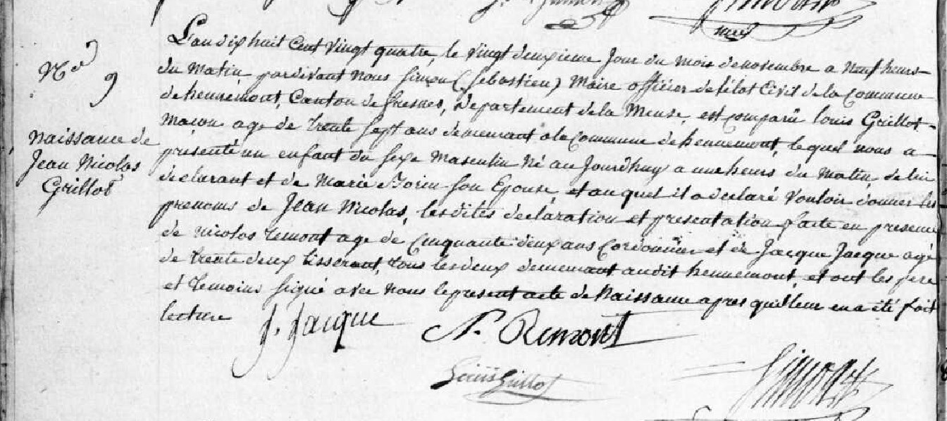
Birth Record of Jean Nicolas Grillot, son of Louis Grillot and Marie Borin
Source: http://archives.meuse.fr
Etat Civil Hennemont 2 E 250 (6)
1823-1832 Births, Marriages, Deaths
Image 23/213

