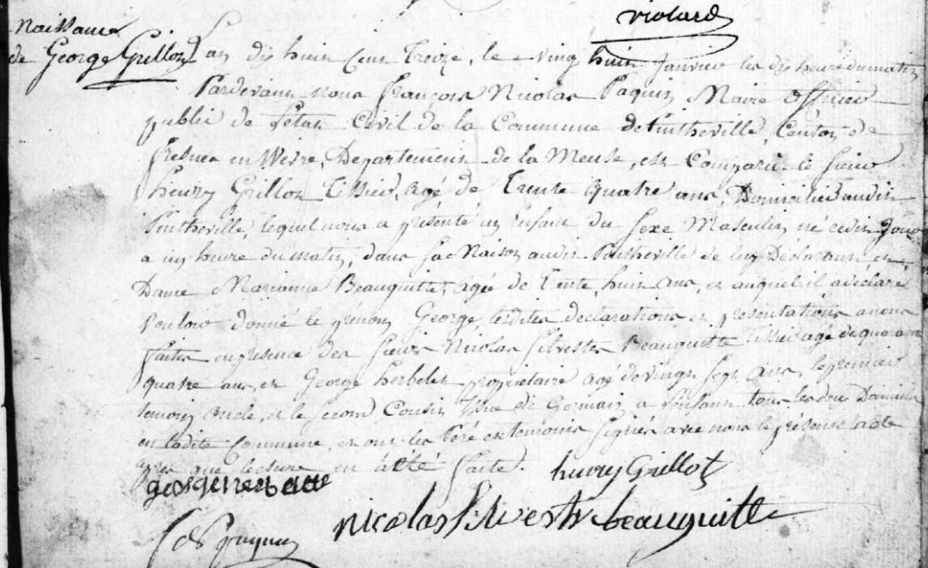
Birth Record of George Grillot, son of Henry Grillot (brother of Louis Grillot)
Source: archives.meuse.fr
Etat Civil
Pintheville, 1813-1822
Image 8/113

