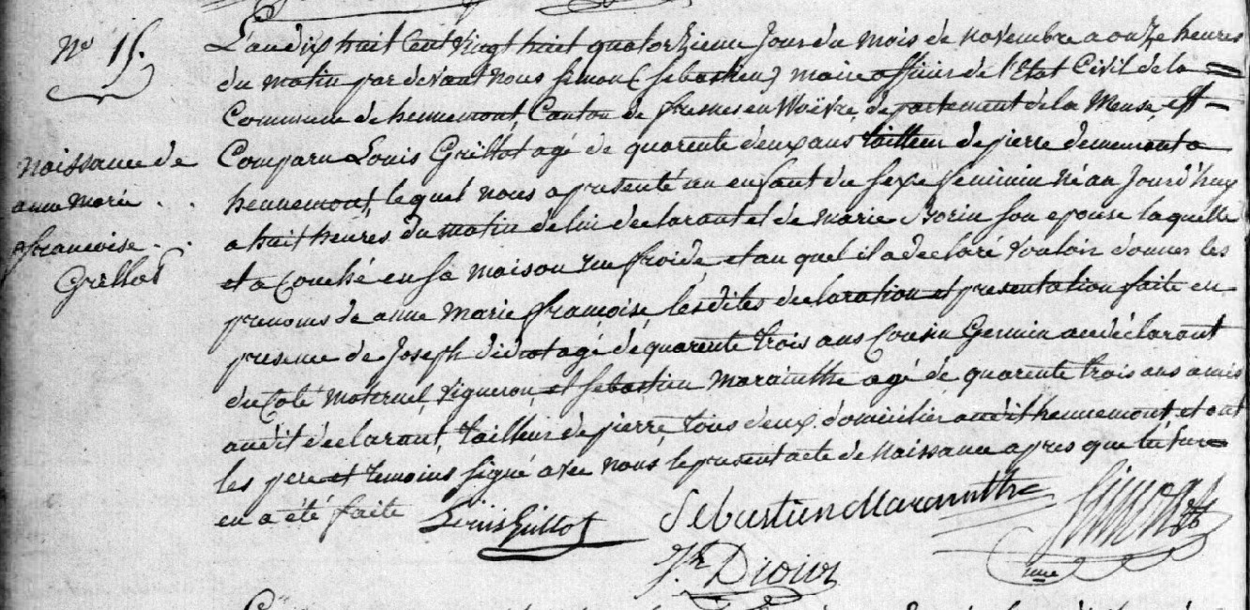
Birth Record of Anne Marie Francoise Grillot, daughter of Louis Grillot and Marie Borin
Source: http://archives.meuse.fr
Etat Civil Hennemont 2 E 250 (6)
Birth, Marriages, Deaths 1823-1832
Image 118/213

