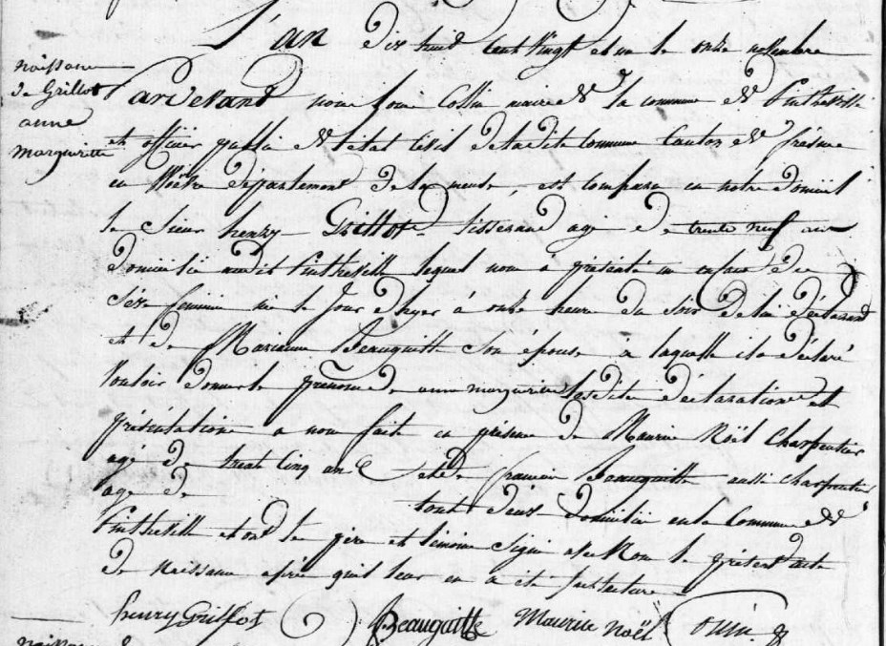
Birth Record of Anne Marguerite Grillot, daughter of Henry Grillot (brother of Louis Grillot)
Source: archives.meuse.fr Etat Civil Pintheville, 1813-1822 Births, Marriages, Deaths Image 91/113

