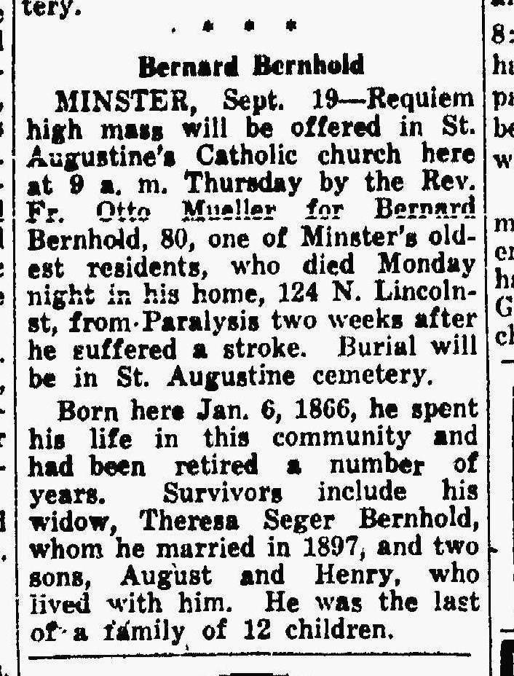

Brother of Anna Bernhold Schroeder
The Lima News
19 Sep 1945
Page four

