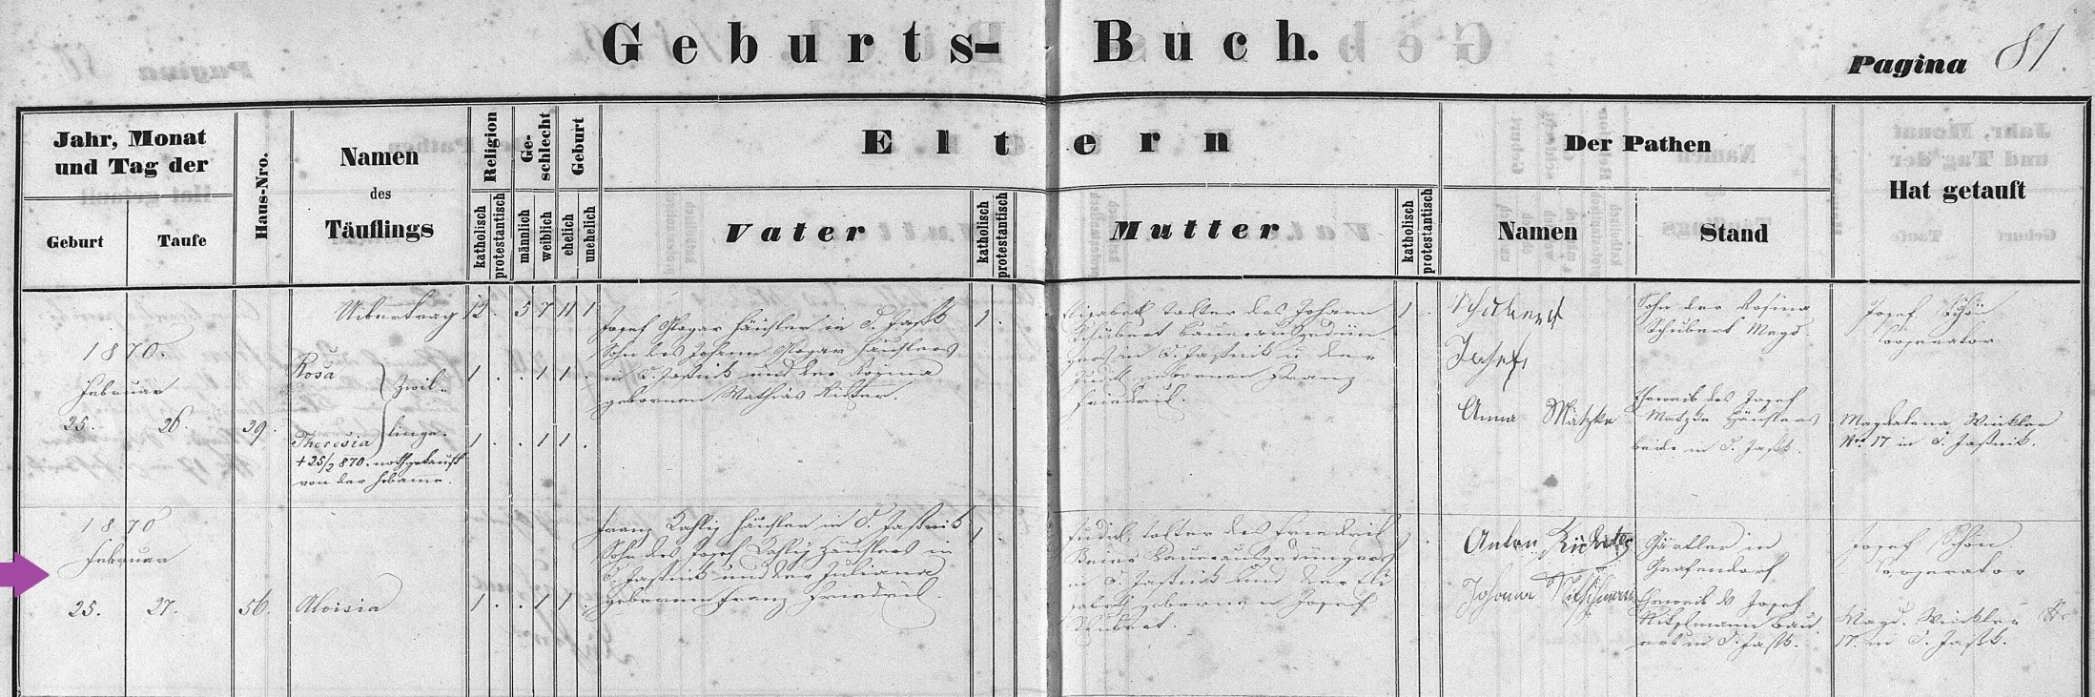
Baptism Record of Aloisia (Louisa) Kahlig Braun, mother of Justina Braun Brunswick
FamilySearch.org
Czech Republic Church Books 1552-1963
Catholic
Novy Jicin
Jesenik nad Odrou
Baptisms 1858-1896 (vol 2049)
Image 84/274

