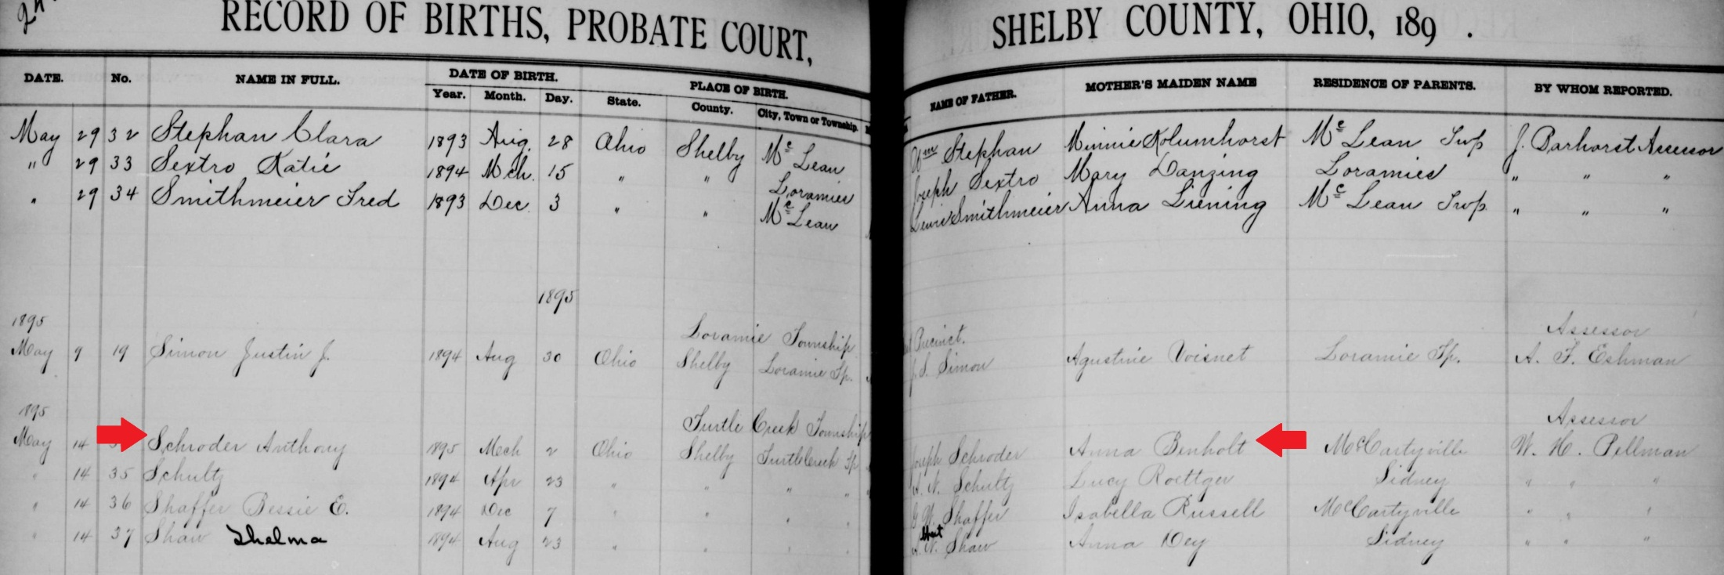
name: | Anthony Schroder
event: | Birth
event date: | 02 Mar 1895
event place: | Turtle Creek Twp., Shelby, Ohio
registration date:
registration place:
gender: | Male
race:
father: | Joseph Schroder
father's titles & terms:
father's birthplace:
father's age:
mother: | Anna Benholt
mother's titles & terms:
mother's birthplace:
mother's age:
additional relatives:
reference number: | v 3 p 244
film number: | 562855
digital folder number: | 004016862
image number: | 00238

Citing this Record
"Ohio, County Births, 1841-2003," index and images, FamilySearch (https://familysearch.org/pal:/MM9.1.1/X6JX-2YC : accessed 29 Jan 2013), Anthony Schroder, 1895.

