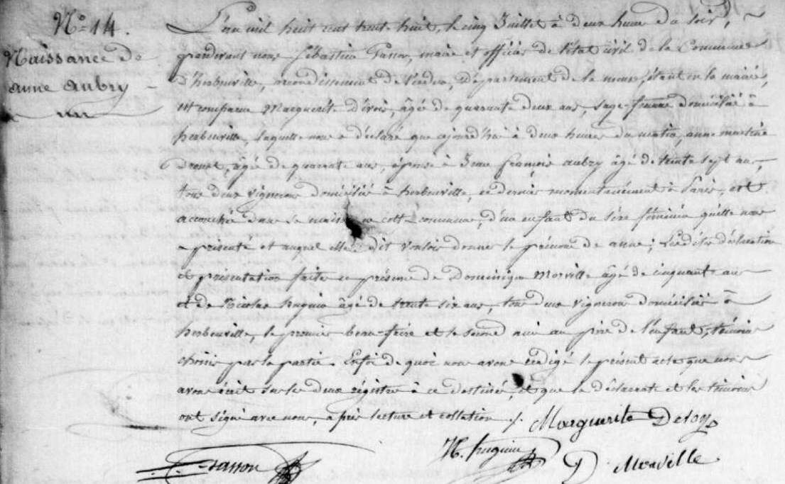
Anne Aubry Birth Record, sister of Marie Anne Aubry Grilliot
Source: archives.meuse.fr
Etat Civil
1833-1842, Births, Marriages, Deaths
Image 246/450

