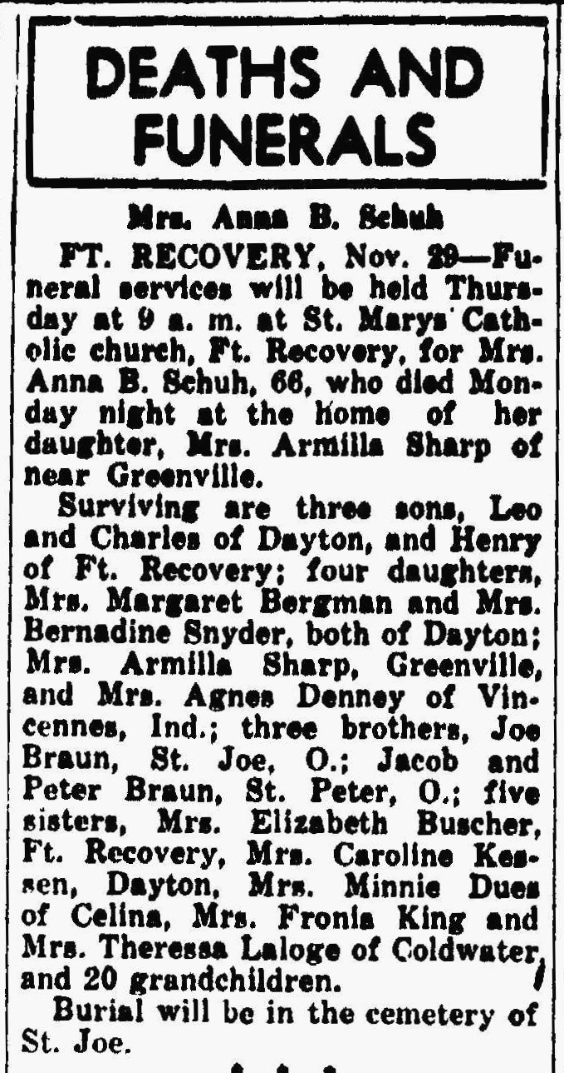
Anna Braun Schuh, half-sister of John M. Braun
The Lima News
29 Nov 1944

