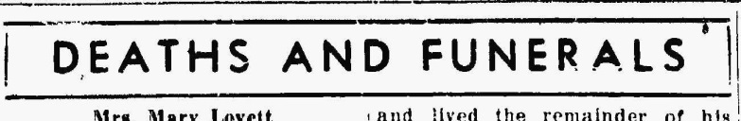
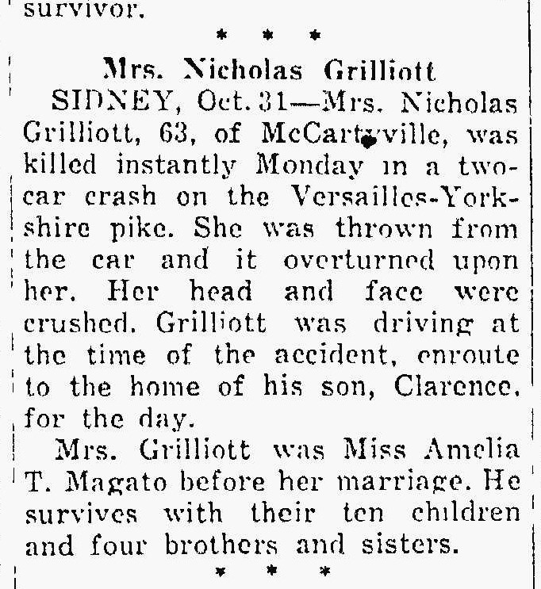
The Lima News
31 Oct 1939
Page 4

