Agnes Drees Hoying, sister of J.M. “Mike” Drees
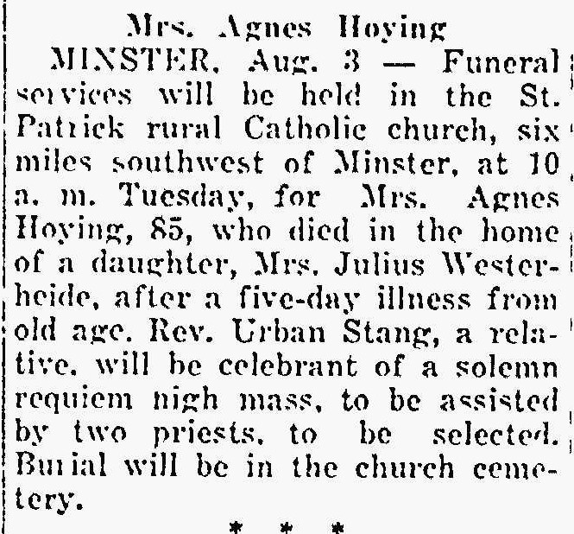
The Lima News August 3, 1942

